Ideation Phase
Empathize & Discover
Date | 26 September 2026
Team ID | SWTID-2026-4413
Project Name | AI FAQ Assistant API
Maximum Marks | 4 Marks

Empathy Map Canvas:
An empathy map is a simple, easy-to-digest visual that captures knowledge about a user's behaviours and attitudes. It is a useful tool to helps teams better understand their users. Creating an effective solution requires understanding the true problem and the person who is experiencing it. The exercise of creating the map helps participants consider things from the user's perspective along with his or her goals and challenges.
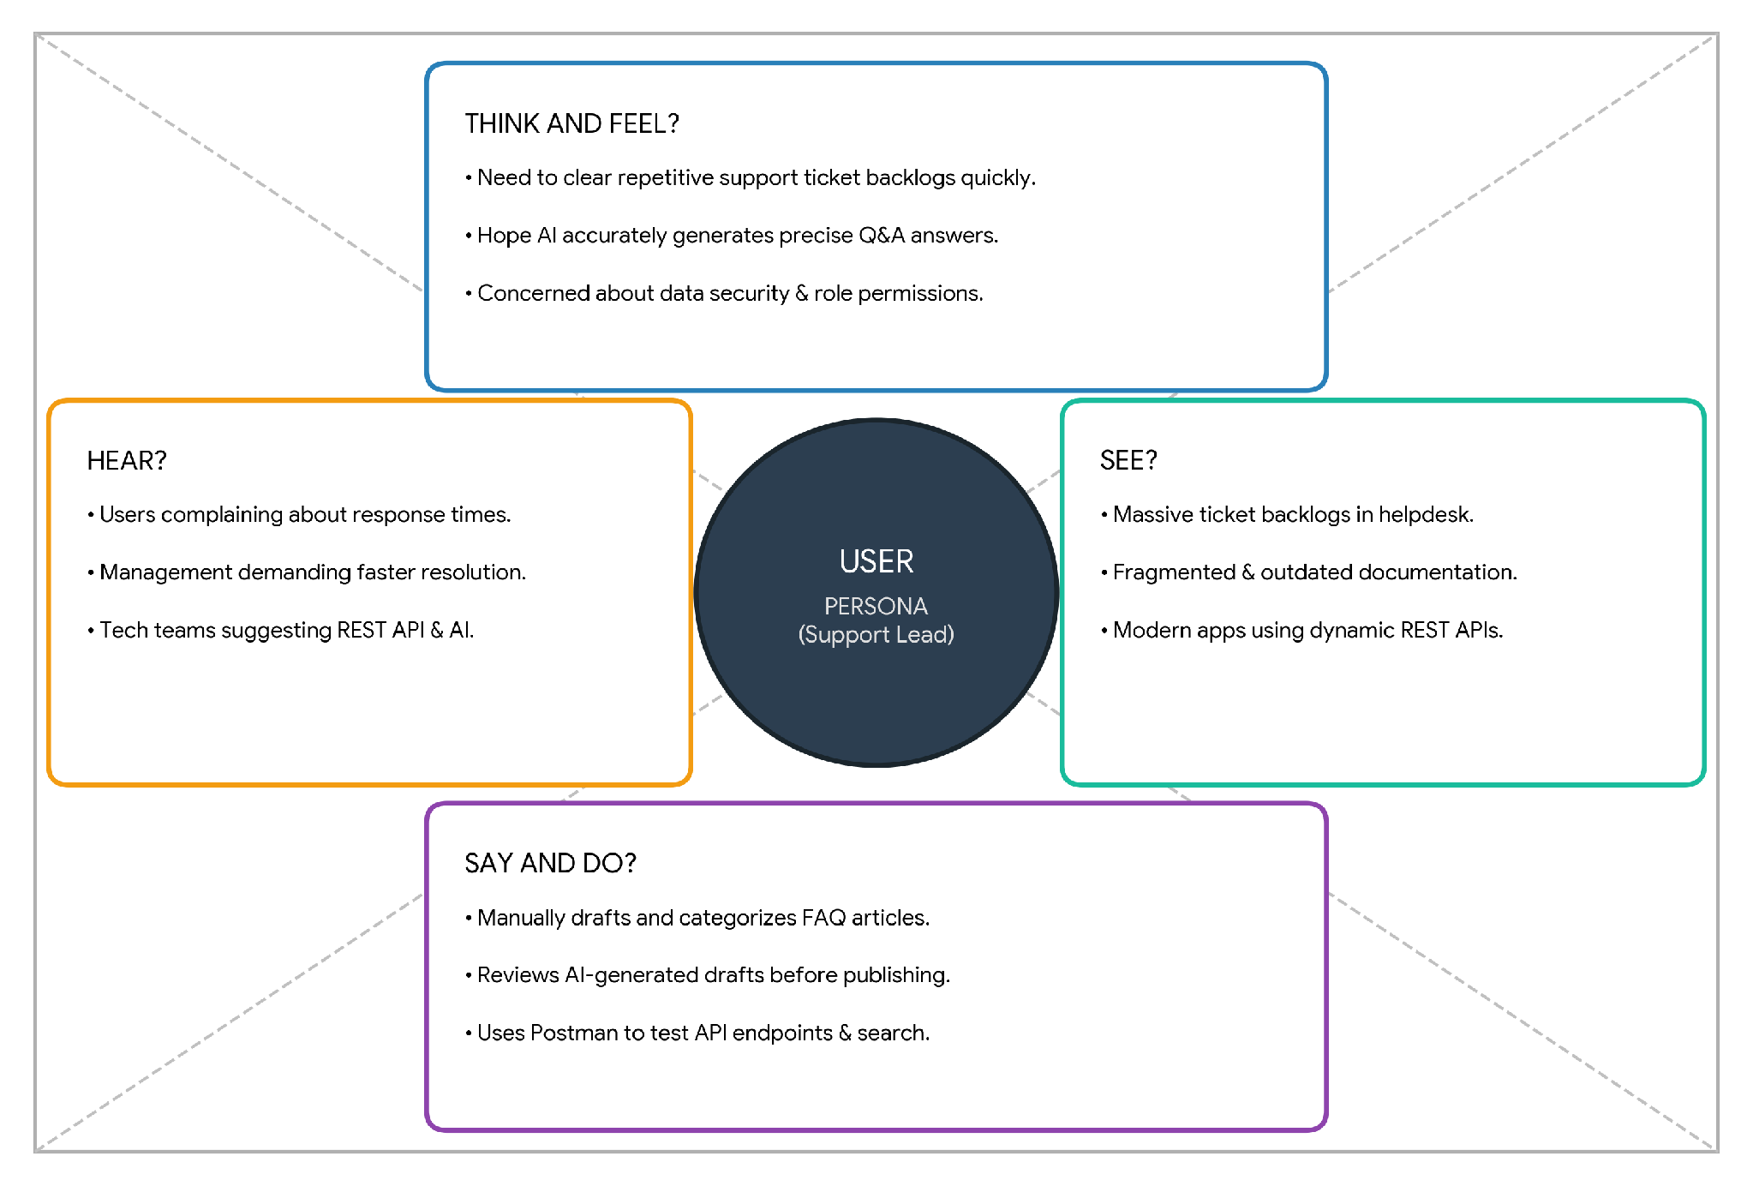
Figure 1: Empathy Map Canvas - Visual Diagram
Figure 2: User Pain & Gain Breakdown Diagram
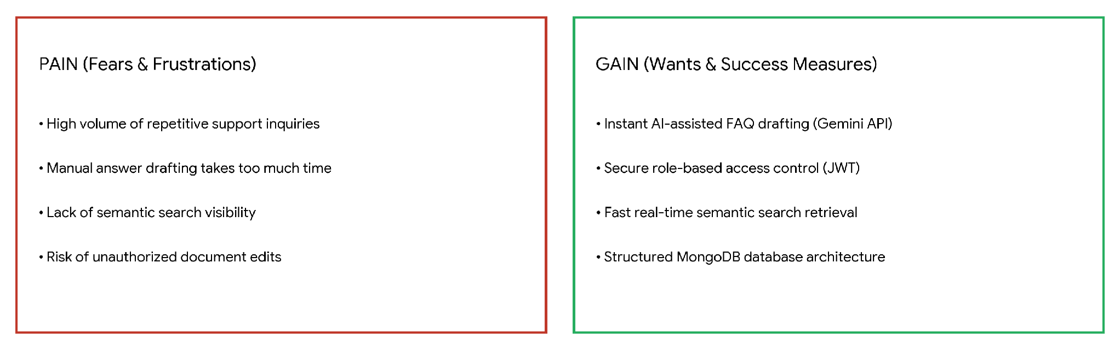
Detailed Empathy Map Matrix Data:
THINK AND FEEL?  What really matters to the user?  • Need to clear repetitive support ticket backlogs quickly.  • Hope AI integration can accurately generate precise Q&A.  • Concerned about data security and unauthorized changes.  • Desire smooth role-based access for admins and authors. | HEAR?  What does the environment say?  • Customers complaining about slow response times.  • Management asking for faster inquiry resolution metrics.  • Tech teams suggesting RESTful API automation.
SEE?  What does the market/environment look like?  • Massive backlog of repetitive user inquiries.  • Fragmented documentation tools without categorization.  • Modern web apps using centralized REST API gateways. | SAY AND DO?  What is the user's behavior towards others?  • Manually drafts support answers and categorizes articles.  • Reviews AI-generated FAQ drafts before publishing.  • Uses Postman / API tools to verify endpoint authentication.
Reference: https://www.mural.co/templates/empathy-map-canvas

